Open the Pod Bay Door – a story game for 2 to 5 players by Bryan Hansel

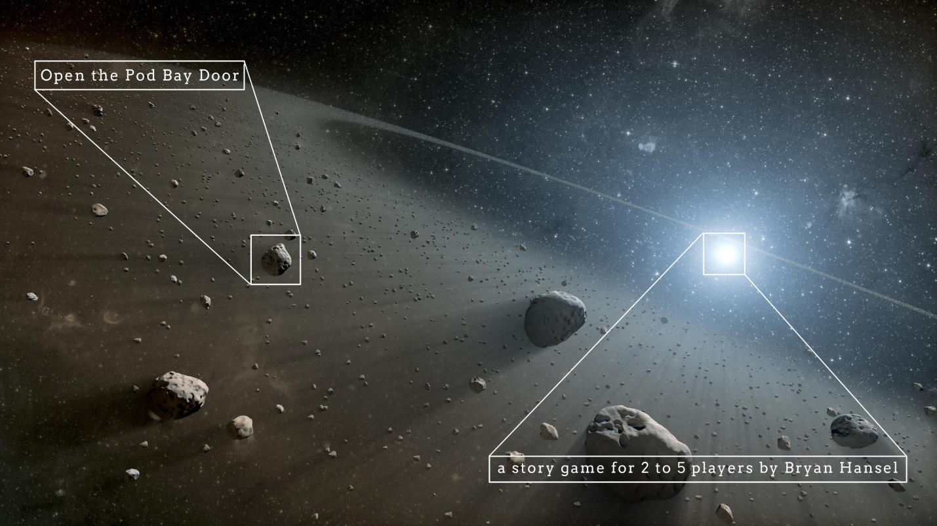
Figure 1: A potential star system for terraforming. Within ½ AU, asteroids and dust surround a bright white-blue star.
This game is my entry in the Game Chef 2013 game design contest using the following theme and ingredients:

Theme: an icon of a robot blocking a stylized starship door.

Ingredient: an icon of a worm coming out of an apple.

Ingredient: an icon of a small spaceship pod with a snowflake painted on its side, two portholes and its thruster engine below

PDF version with play aid is here: Open the Pod Bay Door
You can find this game and others at my Empty Game Box (www.emptygamebox.com). Cover photo public domain and credited to NASA. Icons from game-icons.net by Lorc CC BY 3.0 (creativecommons.org/licenses/by/3.0/).

Open the Pod Bay Door
While investigating a distant star system, the cryogenic, terraforming, colony starship Appleseed became infected by a computer worm. A planetary scouting team was caught outside on the unarmed, short-range pod, the Snow Day. The ship’s infected robot killed everyone awake on the Appleseed and locked the team out. The pod’s air supplies are almost gone…
Note: PDF version with play aid is here: Open the Pod Bay Door

The crew:
- Michelle the Lieutenant Commander
- Lancer the pilot
- Janya the Navy Seal
- Ruhan the computer expert
- Misa the exobiologist
- Kirima the engineer
- Akio the unpaid intern

First Scene
The first player to take a turn plays Michelle on Snow Day’s bridge. Other players play Lancer and Ruhan, and anyone can add outside events. The players must drive Michelle to take an action. After Michelle takes an action – something difficult or something that could cause harm (see Resolving Actions) – proceed to the next section.

Meanwhile, Therefore, But
Before play passes to the next player, the person to the right of the current player picks one word from these three: meanwhile, therefore, but. This works as a conjunction for the next scene. The next player then sets the scene based on the word (see The Next Scenes).
“Meanwhile” takes the play to a completely different scene, area and characters. “Therefore” means that the next scene builds on the last. “But” continues the last scene and introduces an entirely new set of circumstances.

The Next Scenes
Play continues left around the table with each player taking a turn during which he sets a scene, includes characters that aren’t tied up resolving actions and tells us who he is playing. The other players play the other characters in the scene and can add outside events to drive the scene towards an action.
After an action, go back to Meanwhile, Therefore, But and continue until all the characters are either dead or have recaptured the Appleseed.

Add Pressure
The oxygen onboard Snow Day runs out in the two rounds (3 to 5 players), three rounds (2 players). If the crew hasn’t solved this issue somehow, they die. Each character should get to tell the others how she feels about facing death in the void. One round is when all the players have taken a turn.

Resolving Actions

When a character wishes to do something, roll two dice. The first die determines success, and the second the time taken.

If the action is something to do with her job, it succeeds on a 1-4 and takes 1 (1-2), 2 (3-4), or 3 (5-6) turns. If the character attempts something not related to her job, it succeeds only on a 1-3, and takes 2 (1), 4 (2), 6 (3), 8 (4), 10 (5) or 12 (6) turns. If the first die is not successful, the character still spends the full time indicated by the second die.

Track the number of turns that pass during the game. The character cannot be brought into a new scene until the number of turns pass that were required for the action. If all characters are tied up at the end of a round, all actions fail and Something Desperate happens.

Failure
When an action fails and the rolled number of turns passes, pick a player to tell us what has gone wrong. If there was potential of death, roll a die. On a roll of 3-6, the character dies. Tell us how. If others were also in danger because of the action, they also roll.

Something Desperate
A last ditch effort to save the crew occurs. Play enough scenes to allow all the characters to take an action in an attempt to save the crew. If there are more successes than failures, those that succeeded live and those that failed died. Tell us how. Otherwise, they all die. Tell us how.

